###FYI, SOME OF THESE COMMANDS I RAN USING ROOT --- SUDO SU ###

## Week 4 Homework Submission File: Linux Systems Administration

### Step 1: Ensure Permissions on Sensitive Files

1. Permissions on `/etc/shadow` should allow only `root` read and write access.

- Command to inspect permissions: ls -l shadow

- Command to set permissions (if needed): chmod 600 shadow

2. Permissions on `/etc/gshadow` should allow only `root` read and write access.

- Command to inspect permissions: ls -l gshadow

- Command to set permissions (if needed):chmod 600 gshadow

3. Permissions on `/etc/group` should allow `root` read and write access, and allow everyone else read access only.

- Command to inspect permissions:ls -l group

- Command to set permissions (if needed): chmod 644 group

4. Permissions on `/etc/passwd` should allow `root` read and write access, and allow everyone else read access only.

- Command to inspect permissions: ls -l passwd

- Command to set permissions (if needed):chmod 644 passwd

### Step 2: Create User Accounts

1. Add user accounts for `sam`, `joe`, `amy`, `sara`, and `admin`.

- Command to add each user account (include all five users):adduser sam, adduser joe, adduser amy, adduser sara, adduser admin

2. Force users to create 16-character passwords incorporating numbers and symbols.

- Command to edit `pwquality.conf` file: nano pwquality.conf (while in the dir)

- Updates to configuration file: I set (difok = 2, minlen =16, dictcheck = 1, minclass = 4

3. Force passwords to expire every 90 days.

- Command to to set each new user's password to expire in 90 days (include all five users): sudo chage - M 90 sam/joe/amy/sara/admin (typed names separately)

4. Ensure that only the `admin` has general sudo access.

- Command to add `admin` to the `sudo` group: usermod -G sudo admin

### Step 3: Create User Group and Collaborative Folder

1. Add an `engineers` group to the system.

- Command to add group:addgroup engineers

2. Add users `sam`, `joe`, `amy`, and `sara` to the managed group.

- Command to add users to `engineers` group (include all four users):usermod -a -G engineers sam/joe/amy/sara (typed individually)

3. Create a shared folder for this group at `/home/engineers`.

- Command to create the shared folder: while in /home/ typed "mkdir -p engineers"

4. Change ownership on the new engineers' shared folder to the `engineers` group.

- Command to change ownership of engineer's shared folder to engineer group: sudo chown :engineers /home/engineers

5. Add the SGID bit and the sticky bit to allow collaboration between engineers in this directory.

- Command to set SGID and sticky bit to shared folder: sudo chmod +s /home/engineers AND sudo chmod o+t engineers/

### Step 4: Lynis Auditing

1. Command to install Lynis: apt-get install lynis

2. Command to see documentation and instructions: man lynis

3. Command to run an audit: sudo lynis audit system

4. Provide a report from the Lynis output on what can be done to harden the system.

- Screenshot of report output:

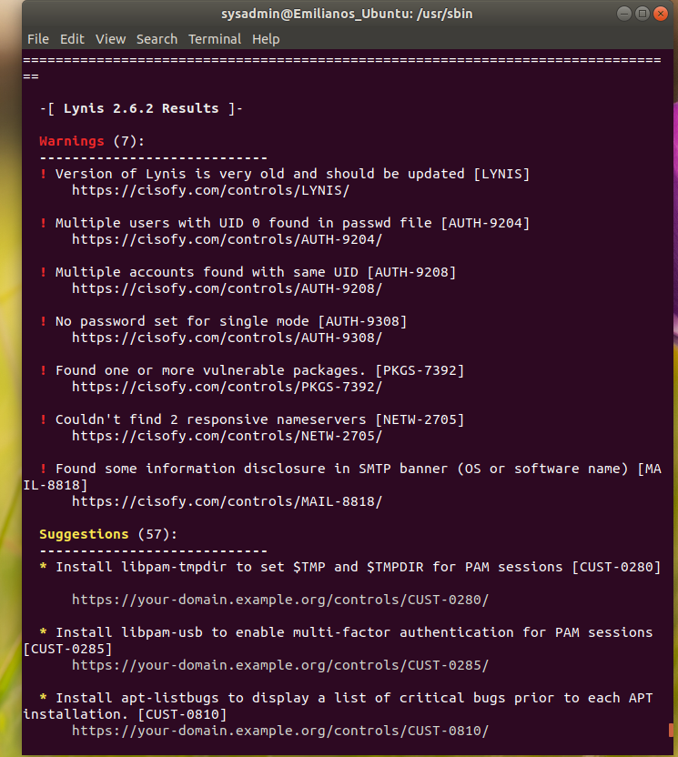

### Bonus

1. Command to install chkrootkit: sudo apt-get install chkrootkit

2. Command to see documentation and instructions: man chkrootkit

3. Command to run expert mode: sudo ./chkrootkit -x

4. Provide a report from the chrootkit output on what can be done to harden the system.

- Screenshot of end of sample output:

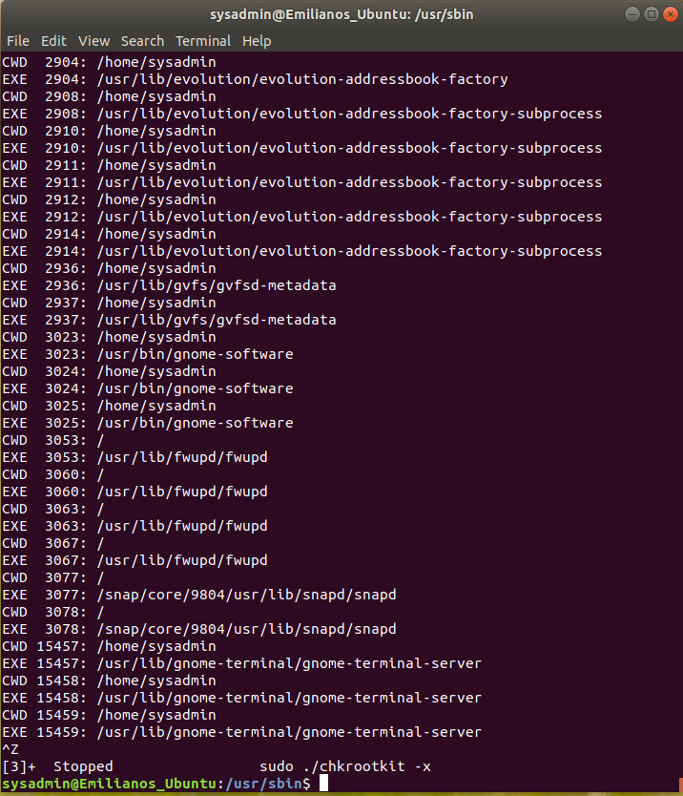

---

Â© 2020 Trilogy Education Services, a 2U, Inc. brand. All Rights Reserved.